Natural Hazards: Tephra Fallout Lab

Name ______________________________________

By the end of this lab, students should be able to:
- understand that every volcanic event is different and so produces a unique deposit
- convert from units of mass/area to thickness
- read a contour plot
- plot a histogram
- consider various tephra hazard mitigation strategies

Tephra: Fragmental material produced by a volcanic eruption regardless of composition, fragment size or emplacement mechanism. Tephra fallout is also commonly referred to as volcanic ash.

For this lab we will utilize the Tephra2 online simulation tool available through Vhub.org. If you do not already have a vhub login you may create an account by clicking the ‘Register’ link in the upper right corner. The Tephra2 tool calculates the sedimentation of tephra on the ground given an eruptive scenario. To access the tool, go to www.vhub.org. Hover your mouse over ‘RESOURCE WAREHOUSE’, and select ‘Online Simulation Tools’. Find and select ‘Tephra2: Student Version” from the Resources column. Click the ‘LAUNCH TOOL’ button to begin using this resource. Once the interface appears, maximize the window.

In today’s lab, we will be investigating the tephra fallout hazard at the city of Leon due to an eruption of nearby Cerro Negro Volcano. As you go through the lab, be sure to answer all of the questions written in bold.

PART I: Learning about the Tephra2 Inputs

We will now explore the inputs accepted by the Tephra2 code. The first parameter asked for is the volcano to consider. Today we will be investigating Cerro Negro Volcano so you can go ahead and select this volcano.

The second parameter asks for the wind field to consider. The ‘Random Cerro Negro Wind Field’ option will randomly sample a list of approximately 1000 wind files, all of which represent actual wind fields measured near Cerro Negro volcano over a five year period. This will produce the most realistic output. For now, however, select one of the constant wind fields.

The third parameter is Eruption Type. What are the options for eruption type? What are the main differences between each eruption type? Hint: Which of the Eruption Parameters change as you select the different eruption types? How do they change?

Now we will move on to the Particle Parameters tab under Eruption Parameters. For this lab we will use the default values. What is the default value for the maximum grainsize erupted, in mm? Hint: if you view the available grainsizes, your options are displayed in metric units.

What is the default value for the median grainsize erupted, in mm?

What is the default value for the minimum grainsize erupted, in mm?

What is the density of the particles being ejected from the vent? Be sure to include units.

The DEM tab allows you to create a grid for input to the program. Tephra accumulation is calculated for each grid point. For now, you may leave all DEM parameters at their default values.

The Simulation Parameters tab describes the type of column model that the program will use. Select multiple particle release heights and examine the associated image. Return the column model to its default (Particles released from upper 20% of column). Draw the cartoon column corresponding to this model. Label both the volcano and the eruption column. What does the vertical line represent? Explain.

Finally, select the images tab. Here you will find a photograph and location map of Cerro Negro volcano. Describe the volcano. What type of volcano is it?

Considering the type of volcano in question, name at least one volcanic hazard, other than tephra fallout, that might pose problems given an eruption at Cerro Negro volcano. Explain why you chose the hazard you chose.

Find Leon on the location map. How far away from the volcano is the city? In what direction, relative to the volcano, is the city located? Hint: hold a piece of paper to the screen and use as a ruler.

Okay, now that we understand the inputs, we are ready to run our first simulation. For the moment, leave both the ‘Compare model result to field data?’ and ‘Re-use previous wind field?’ boxes unchecked. You may select whatever eruption type you like. Select one of the two constant wind fields while leaving all other parameters at their defaults. (If you have already altered the defaults, simply close the application and re-launch the tool). Hit the ‘Simulate’ button and wait for the program to run.

Eruption Type: ___________________________________ Wind Field: _____________________________________

The code provides multiple outputs. Briefly describe each of the outputs listed below. Be sure to note what type of data is plotted on the graph.

Isopach Map -

Tephra2 Ouptut -

Tephra2 Model Inputs –

Tephra2 Wind Input -

Select the ‘Isopach Map: No Togpography’ window. Note that this option plots only the area over which calculations were made while the map with topography has a constant, pre-defined size. The contour lines on this plot are called ‘isopachs’. Based on this plot, what does an isopach represent? What are the SI units associated with these isopachs? Hint: clicking the magnifying glass to the left of the image will enlarge the plot making it easier to read.

Sketch a representative number of isopachs in the space below. Where is tephra accumulation greatest?

Cerro Negro Volcano

Predict how the accumulation of tephra will change if you select the other constant wind field. Draw your prediction below.

Wind Field: _____________________________________

Cerro Negro Volcano

Clear your result by selecting the ‘clear’ button in the lower right corner. Return to the inputs section by selecting ‘Inputs’. Run the simulation again, this time selecting the other constant wind field. Was your prediction correct? Explain.

PART II: Varying the Eruption Parameters and Examining the model Output

Okay, now we are really ready to get going. We want to know, if there is an eruption at Cerro Negro volcano, how thick will the deposit be at the population center of Leon. Why might it be important to know this information?

In this section we will be examining the accumulation of tephra given
A) a single wind field, but varying eruption parameters and
B) a single eruption, but varying wind fields

We will begin with (A). Use the wind field ‘Constant From the Northeast’. This option mimics the strong trade winds present in the area. Vary the eruption parameters. Any combination of column height and mass other than the defaults will be fine. Begin by simulating a Violent Strombolian eruption.

Examine the resulting Isopach map. Approximately how much tephra accumulation is expected at Leon in the scenario you just modeled (be sure to include units)? The Isopach map without topography is easier to interpret. It may be necessary to zoom by selecting the magnifying glass button to the right.

Rather than the mass/area of tephra accumulated, we would really like to know the thickness of tephra. How do we translate from units of mass/area to units of thickness (cm)? Write down the equation to translate the output from Tephra2 into cm of thickness. Label the mass/area variable ‘Code Output’. Hint: you will need use the particle density from the Particle Parameters tab.

Residential roofs begin to collapse once the thickness of tephra reaches approximately 10cm. Which Isopach line is closest to representing this value? Hint: solve for ‘Code Output’ from the above equation

For each Eruption Type, select values other than the defaults and run the simulation. On the resulting Isopach maps, locate the Isopach which represents possible roof collapse. Sketch this Isopach on the map below. Be sure to label which Eruption Type was responsible for each Isopach. Hint: You will not always be able to see the exact location of the isopach in question. In these cases, estimate its position.

Varying Eruption Style: Isopachs Representing Possible Roof Collapse
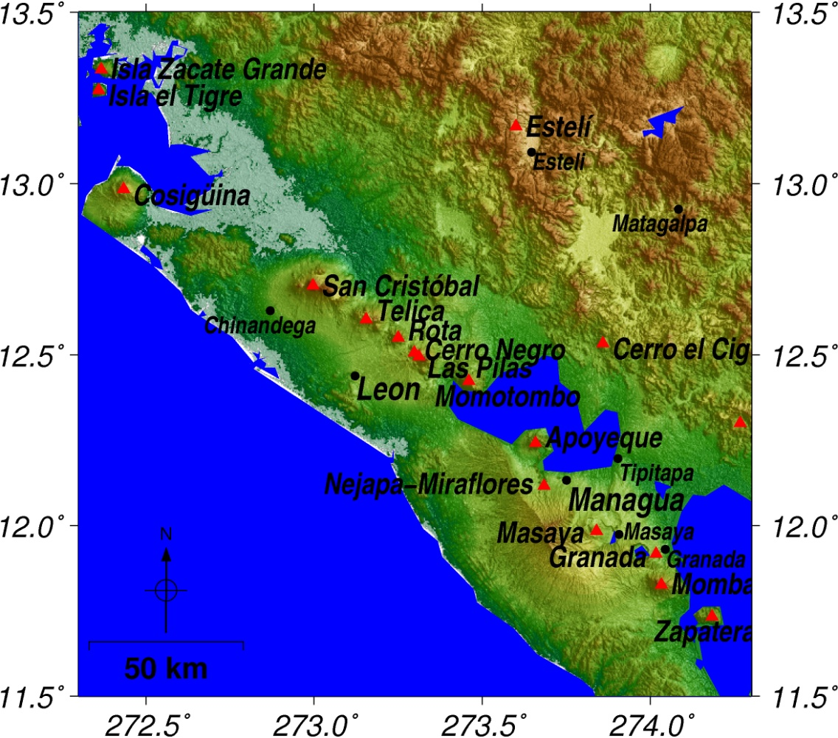

Explain what happened to the area vulnerable to roof collapse as the eruption type changed.

Now on to (B). Set the column height to 7km and the total eruption mass to 0.25 x 10^11 kg. For your wind field, select ‘Random wind field: Cerro Negro dataset’. Change the DEM parameters to plot 50 km in each direction (this will speed up the model). Hit simulate. Examine the resulting Isopach map. Record the amount of tephra accumulated at Leon in the table provided on the following page. Note: it may be easier to read the contours plotted without topography. Run this simulation an additional 19 times in order to fill in the table provided. You must run the first ten simulations on your own. You may consult with a partner to fill out the remaining half of the table. You will need to press the ‘Clear’ in between each run.
Variable Wind

Run Number | Tephra Accumulation in Leon
 | (M/Area) | (cm)
1

2

3

4

5

6

7

8

9

10

Now that we have all of this data, we need to display it in a way that makes sense. One option is to make a histogram. Transform your data into a histogram plot using the graph provided below.

Given a Violent Strombolian eruption at Cerro Negro Volcano, what is the most likely range of tephra accumulation in Leon? How do you know?

What three crucial pieces of information would we need in order to make an accurate prediction of the thickness of tephra fallout at Leon for a particular eruption?

The eruption parameters used for the previous exercise mimic an actual eruption that occurred at Cerro Negro on the 9-14th of April, 1992. This eruption resulted in >2 cm of ashfall in nearby Leon. Why does the value of tephra deposited in Leon not equal the most likely thickness of tephra accumulation that you got from your histogram? Explain.

Before moving on to the next section, we will add your data to the class dataset hosted on vhub.org. Go to the vhub.org home page and select ‘Members: Groups: GLY 2030: Hazards of the Earth’s Surface’ and click the ‘Join Group’ button. Under ‘Discussion: Tephra2 Probabilistic Analysis’ you will find two discussions. Select ‘Data: Results of 10 runs per student’ and follow the directions to post your data as a comment. Select ‘Data: Results of binning the data’ and follow the directions to post the information from the histogram you created above. We will compile the results in class and use them to re-examine your responses to the preceeding questions during a class discussion.

PART III: Hazard Mitigation

Now we will move on to consider some of the harmful affects of tephra fallout and how these effects can be mitigated.

Complete the table below by
- Provide the accumulation at which residential roofs begin to collapse that you calculated at the bottom of page 5.
- Brainstorm two additional harmful effects that volcanic ash fall can cause. You do not need to know at what accumulation these hazards become significant.

DAMAGE DUE TO ASH FALL | ACCUMULATION
Crop Damage begins to occur | 10 Mass/Area (0.8cm)
Roof Collapse for common structures begins | (10 cm)
Roof Collapse is widespread (for common structures) | 240 Mass/Area (20 cm)
 | X
 | X

How might you mitigate each of the harmful effects above?

Based on the table and your results so far, do you think that the city of Leon needs to worry about ash fallout as a potential hazard? Explain.

We will now consider the worst case scenario for an eruption from Cerro Negro Volcano. Clear your results and return to the inputs portion of the user interface. Switch the eruption type to ‘Subplinian’. Set the eruption column height to 8 km and Total Mass Ejected to 1.2 x 10¹¹ kg. Select the ‘Worst Case Scenario’ wind field. Hit simulate. Note: The above values were taken from Connor et al, 2001. What is the tephra accumulation in Leon, in cm?

Based on the worst case scenario, do you think that the city of Leon needs to worry about ash fallout as a potential hazard? Explain.

Considering the worst case scenario, your previous model runs, and the values given in the table above, draw and label the following on the plot below:

• Where might it be a good idea to prohibit building?
• Where should building fortifications required?
• Where might a public education campaign be useful for mitigating the volcanic hazard?
• Define a mandatory evacuation zone.

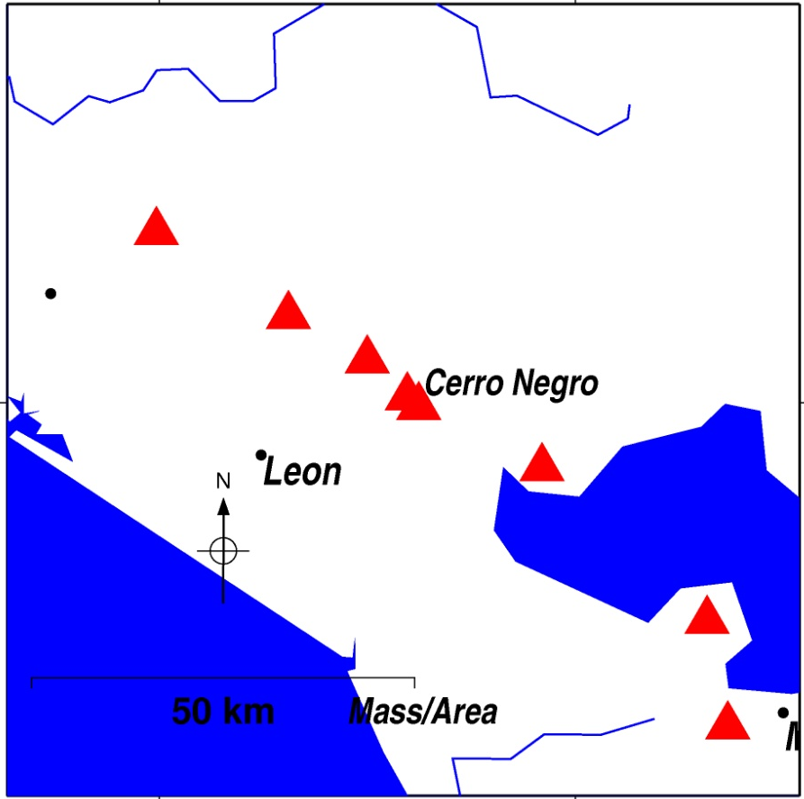
Give a brief explanation of why you placed the boundaries where you did. Hint: Think about whether or not one should plan for the worst case scenario. There is no one correct answer as long as you can explain your reasoning.

